Assignment M02
Steve Mazza

Part 1

Diagram 1
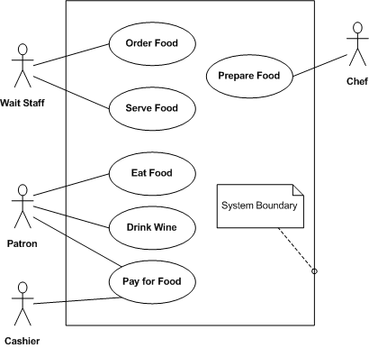
This is a Use Case diagram. It consists of Actors and Use Cases contained within a System Boundary and is intended to provide context for the activities to be performed within a system by focusing on the Who and the What but not the How (implementation).
This particular diagram describes the high level operation of a restaurant from the perspective of its employees and patrons. It shows a division of labor and responsibility as follows. The Wait Staff performs the Order Food and Serve Food activities, the Chef performs the Prepare Food activity, the Cashier performs the Pay for Food activity, and the Patron(s) perform the Eat Food, Drink Wine, and Pay for Food activities.
Notice that there is no attempt to indicate if a Use Case is optional or mandatory; all Use Cases are simply available as indicated.

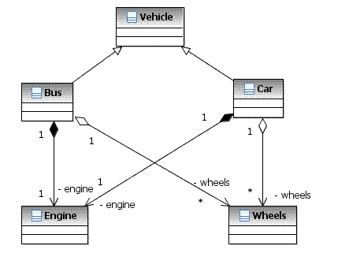
Diagram 2
This is a Class diagram. It consists of a set of interrelated classes with their relationships indicated by arrows. The specific drawing of the interconnecting lines indicates relationships such as “is a” and “has a” and the cardinality of the given relationship (e.g., many-to-one).
In this diagram Vehicle is a base class for both Bus and Car which each have an Engine and Wheels at a distribution of one-to-one and one-to-many, respectively. A Car is a Vehicle and has an engine and Wheels. For simplicity, the details of the classes have been omitted but could include both members and functions.

Part 2
Part 2. Short Paper Assignment: Consider the three papers in this week's reading assignment and write a short paper (350-700 words, or about half a page to one page) addresssing the following:
- Summarize briefly the main ideas or themes of two of the papers. (Just a couple of sentences will do if they capture the essence of the papers.)
- What parts of each paper did you agree with? What parts did you disagree with? How do the statements made in the papers measure up with your experience? (This should be the bulk of your paper - I am interested in your reaction to the ideas based on your experience/knowledge.)
- At the end of your paper, include one or two discussion questions you have based on your thoughts and ideas while completing the assignment. (These questions will normally be used during class to stimulate discussions, but they also help you solidify your thoughts. If you can compose an interesting question about a topic, it reveals that you understand the concepts.)

